‘POLIS’ - Political Learning and International Society

Mobility on improving tools and methods in the context of political education and fostering a more globalized and interconnected society.

26.02. - 05.03.2024, Bratislava, Slovakia

Themes of the mobility:
The POLIS project aims at political education of youth workers, understanding their attitudes towards democracy and political participation, and inclusion of young people in formal political processes. Furthermore, this project addresses issues related to governance, corruption, voter apathy, and the consequences of social media on political development. The goal of this mobility is to heighten political awareness, encourage civic engagement, and contribute to the growth of well-informed and actively involved citizens.

The overall aim of the mobility program is to improve the ability and skills of young people for being capable of inventing and implementing different tools and methods to promote responsible action and stimulate willingness to take or demand action at local, national, and global levels of politics, fostering empathy, and responsibility.

Learning objectives of the training are:
- To deeper understanding of the participants and participating organisations on the issues related to governance;
- To increase competences of the participants and participating organizations to address corruption, voter apathy, and the issues connected with the use of social media for political purposes;
- To develop competences of the participants and participating organisations to create and launch campaigns, awareness raising actions to increase the participation of young people in the public affairs;
- To strengthen competences of the participants to effectively use various media, including social one, as tools for awareness raising on the issue of fake news and misinformation;
- To develop communication, teamwork, leaderships skills of the participants in intercultural settings;
- To support creating new contacts among the participants and their organizations and developing new projects ideas that could be implemented with support of Erasmus+ Programme.

The methodology of the mobility:
The mobility will be based on non-formal learning methodology such as name games, ice-breakers, team building activities, discussions on non-formal education and its elements, presentation of Youthpass, exploring key competences through group work, energizers, individual work, group work, interactive inputs on main topics, discussions, debates, role plays or simulations. During the days, the participants will take part in reflection groups to reflect on their learning process. Participants will receive input on key elements of campaigns, will get to know several tools that they can use in the process of creating campaigning and work on their own ideas for campaigns. Participants will be responsible for launching these campaigns in their communities. Experienced international trainers’ team will set up the learning environment and facilitate the learning process.

Who can participate in the training:
-Youth workers from 18 years old;
- Ready to take part in the whole mobility;
- Be interested in the topic of political education and governance;
- Be able to communicate in English language.

Eligible countries: Czechia, Hungary, Italy, Latvia, Lithuania, Romania, Spain, Slovakia

Applicant organisation: Bratislava Policy Institute (BPI) is an independent not-for-profit think tank dedicated to fostering liberal democracy, human rights, Central European region, and European integration through analysis and debate, supporting and challenging relevant stakeholders at national and international levels to make informed decisions based on evidence and analysis.

The food and accommodation will be provided and paid by the organisers. Travel costs will be counted based on the distance calculator of the European Commission and reimbursed by bank transfer after the course (in Euros €) through the sending organisations.
Max. travel cost according to distance calculator:

Slovakia – 0 EUR (5 participants)
Czechia – 180 EUR (5 participants) – green travel 210 EUR
Hungary – 180 EUR (5 participants) – green travel 210 EUR
Italy - 275 EUR (5 participants) - green travel 320 EUR
Latvia - 275 EUR (5 participants) – green travel 320 EUR
Lithuania – 275 EUR (5 participants) – green travel 320 EUR
Romania – 275 EUR (5 participants) – green travel 320 EUR
Spain – 360 EUR (5 participants) – green travel 410 EUR

What to bring with you?
- Your passport or ID card
      - All your travel tickets!!! (it is very important to keep all your ticket, receipts, and boarding passes, because we can give you back the travel costs only if you have the tickets)
      - National snacks, drinks, easy food, specialties, local music for the cultural evening
      - Medicines - if you need them (anti-allergy pills, pain killers, Aspirin etc.)
      - Laptop, camera – it is not obligatory, but it can be useful

Weather
Before leaving your home country please check the weather forecast at:
https://www.meteo.sk/
Usually the weather is cold in February, with some rain or snow.

Accommodation
The daily activities will be taking place in BUSINESS CENTRUM, which is located on Zochova 5 in Bratislava. We will be accommodated in Apollo Hotel, on Dulovo námestie 1. Food will be arranged by the organisers, there will be three meals every day: breakfast, lunch and dinner; and coffee breaks.

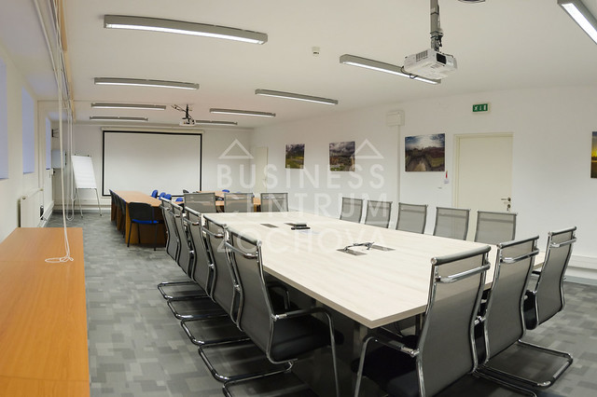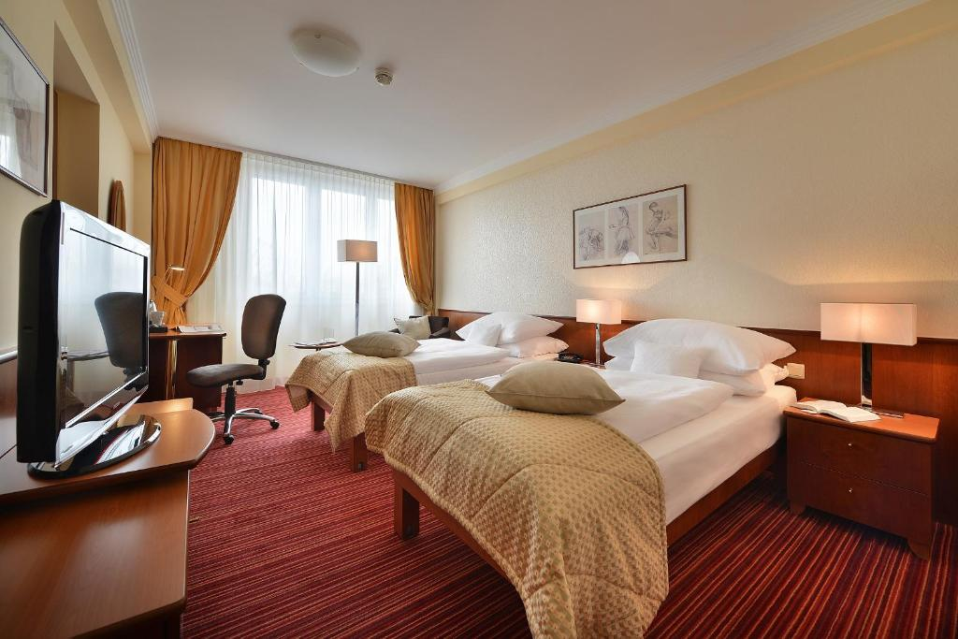

How do you reach Bratislava?
BRATISLAVA AIRPORT (BTS)
There are direct flights to several destinations in Europe and many airlines that operate their direct routes to Bratislava – RYANAIR, Pobeda, Flydubai, Smart Wings, Air Cairo, Wizz Air. Bratislava airport can be reached from the city centre in 15–20 minutes. To get to the city centre you can take a taxi – do not forget to ask about the price in advance or use HOPIN, BOLT, UBER mobile app. You can take a bus no. 61 to the main train station as well. From there, you can walk to the city centre in 15 minutes or take a bus no. 93 (exit: Hodžovo námestie) or tram no. 1 (exit: Námestie SNP). Bus tickets are available in ticket machines at bus stops or in kiosks. The tickets which cost around EUR 1,20 must be validated in the buses.

VIENNA-SCHWECHAT (VIE) AIRPORT
The airport at Vienna-Schwechat is only 40 kilometres west of Bratislava and Slovaks mainly use it for long-haul flights. It is one of the main gateways to Slovakia. Buses to Bratislava depart at 30 to 60-minute intervals. Tickets can be bought in the bus; check the following companies eurolines.sk, regiojet.com, flixbus.com.

BY TRAIN
Bratislava connects to the main lines from Prague, Budapest, Vienna, and various regions in Slovakia. Bratislava has two railway stations – the main train station “Hlavná stanica” and Petržalka. The main train station is well connected to the rest of the city via trams, buses or trolleybuses and you can get to the Old Town by foot in only 15 minutes. From the train station in Petržalka, buses no. 80, 91, or 93 can take you to the city centre.

BY BUS
Bratislava is also conveniently connected with many European cities via a network of bus lines. It has frequent service to the surrounding areas and to other regions in Slovakia. Buses arrive and depart from Mlynské Nivy bus station. Coaches between Bratislava and Vienna run at one-hour intervals: eurolines.sk, regiojet.com, flixbus.com.

BY BOAT
Due to its position on the river Danube, Bratislava has regular connections by boat with Vienna. The centre of Vienna (Schwedenplatz) is connected to Bratislava by a fast catamaran Twin City Liner and another fast hydrofoil, which is berthed at Vienna Handelskai.

BY CAR
Bratislava is situated at the intersection of several important motorways. The distance to Prague is 330 km, Budapest 200 km and Vienna 65 km. If you are bringing your own car, you need to display a valid motorway tax sticker (known as ‘diaľničná známka’), available at borders or petrol stations. The minimum validity period is 10 days (costs around 10 EUR).

QUARANTINE MEASURES
From 6th of April 2022 there are no restrictions for anyone coming to Slovakia.
If you have any questions please feel free to contact us on wagingerova@bpi.sk

Preliminary programme:

Hours | Day 1  Arrival day  26th February | Day 2  Getting to know day  27th February | Day 3  Learning day  28th February | Day 4  Day of campaigns  29th February | Day 5  Trip day  1st March | Day 6  Engage youth day  2nd March | Day 7  Day off  3rd March | Day 8  Evaluation Day  4th March | Day 9  Departure Day  5th March
9.00  –10.00 | Arrival of participants - Registration | Breakfast | Breakfast | Breakfast | Breakfast | Breakfast | Breakfast + Lunch to go | Breakfast | Breakfast
10.30–11.30 |  | Getting to know each other | Morning warm up | Introduction to campaigns  +  Personal and Group Action Plan | Field trip | How can be young people engaged in public affairs?  - informal debate | Day off | Fill in Youthpass certificate – dialogue space
11.30–12.00 |  | Coffee break | Coffee break | Coffee break |  | Coffee break |  | Coffee break
12.00–13.00 |  | Introduction for the mobility  aim and goals  Day by day program | What is governance? | Work on campaigns |  | Mobilisation of young people |  | Presentation of campaigns  +  feedback
13.00–14.00 |  | Lunch | Lunch | Lunch | Lunch | Lunch |  | Lunch
14.00 –  15.00 |  | Non-formal education  Erasmus+ program  - Youthpass | Exploring realities of participants’ countries | Work on campaigns | Field trip | Democracy awareness-raising in practice  - expert presentation |  | Presentation of campaigns  +  feedback
15.00 –  15.30 |  | Coffee break | Coffee break | Coffee break |  | Coffee break |  | Coffee break | Departure of participants
15.30–16.30 |  | Team building activities | Influence of social media on political development  - expert presentation | Work on campaigns |  | Concluding thoughts and remarks on the topic |  | Evaluation of the mobility  +  Youthpass
18.00  –19.00 | Dinner | Dinner | Dinner | Dinner | Dinner | Dinner | Dinner | Farewell dinner
19.00  –21:00 | Welcome evening | Intercultural evening | Quiz | Free evening with several options | Night out | Karaoke evening | Movie  evening | Goodbye  party

APPLICATION FORM

PERSONAL DATA
First name:

Family name:

Nationality:

Date of birth:

Gender:

Complete address:

Postal code:

Town:

Country

Phone number:

Fax:

E-mail:

Do you have any special needs or requirements that the host organisation should know about? (E.g. mobility, medical needs, allergies, dietary restrictions, smoker/non-smoker)

Language(s) abilities: Please mention all languages in which you can work and indicate your level for each (B-basic, G-good, VG-very good, F-fluent, MT-mother tongue). The main working language of he mobility will be English.
 | Listening | Speaking | Reading | Writing
English
Other languages

KNOWLEDGE AND EXPERIENCES
What is your level of knowledge about listed: |  | Low | Medium | High
 | EramusPlus (previously "Youth in Action") programme in general
 | Mobility of young people: Youth exchanges
 | Mobility of youth workers: Youth worker's trainings and networkings
 | Mobility of young people: European Voluntary Service (EVS)
Please shortly describe your experience in the YiA and Erasmus+ programme and the actions above.
(E.g. type of projects, your role - organiser / participant / trainer or facilitator etc.)

MOTIVATION AND EXPECTATIONS
What would you like to learn, understand, and experience during this mobility?

What contributions can you bring for the mobility?

How do you plan to use the experience from this mobility afterwards?

Please indicate us the name and full contact details of a person to be contacted in case of emergency during the seminar:
First name:

Family name:

Complete address:

Postal code:

Town:

Country

Phone number:

Fax:

E-mail:

Web:

Please take note of the following conditions that will apply, if you are selected to take part in the partnership building seminar.
- I commit myself to participate in the whole process, including:
- to prepare myself carefully for the partnership building seminar and to do all remote preparation work the team will ask for,
- to take part in the full duration of the partnership building seminar,
- to participate in the whole evaluation process.
- I understand that the information I provided on my special needs does not remove my own personal responsibility for ensuring my own health.

